REPORT WRITING (Word count: 2000 words (+- 20%))

Executive summary

Introduction
Tourists frequently encounter two critical challenges that hinder the quality of their travel experiences. First, itinerary planning is highly fragmented, with information about attractions, transportation options, and ticket bookings dispersed across multiple platforms, requiring considerable time and effort to coordinate. Second, accessing to authentic local experiences is often limited, as cultural events, food festivals, and niche activities receive insufficient visibility in mainstream travel tools, resulting in missed opportunities for engagement. These inefficiencies not only reduce visitor satisfaction but also constrain the economic potential of local businesses and event organisers.

To address these challenges, this project proposes the development of TripMate, a mobile application that integrates artificial intelligence-driven itinerary planning with personalised, location-based cultural and event recommendations. By consolidating essential travel functions into a single platform, the application aims to streamline the planning process, reduce the time spent on information searches, and increase tourist participation in local activities. Through automated itinerary generation and real-time cultural insights, the solution seeks to transform the way travellers engage with their destinations.

TripMate addresses both time efficiency and experiential enrichment by combining dynamic itinerary generation with location-aware cultural discovery. This integrated approach creates value for multiple stakeholders: tourists benefit from optimised and personalised travel experiences, local businesses gain increased customer engagement, and event organisers achieve greater visibility. Ultimately, TripMate LocalGems offers a unified, intelligent platform that enhances trip satisfaction while fostering sustainable local tourism and economic development.

Method - Design Thinking Approach
The method gone through a process of design thinking approach of empathise to defining, which aim to understanding the customer/ users behaviour and identifying their needs of having an all-in-one app for their traveling journey, then the process come to the stage of ideating, which creating ideas in ideation session to reach as many solutions as possible and all the solutions will be putting all together to make a product that satisfy the users’ requirements (Lynn writing draft)

Empathise - how you gathered insights into the problems (interviews, secondary data, observation) (Empathy Map)
- Explain how you identified user needs (interviews, secondary research, observation)
- Include Empathy Map
Given the increasing smartphone use rate in recent years, mobile applications (apps) can substantially impact business. Mobile cloud computing, Internet of things (IoT), artificial intelligence (AI), blockchain tools and apps are transforming hospitality into a fully digital technology-enabled industry. The evolution of smart devices and the risk of AI technology have shifted mobile travel apps (MTA) towards smart features, which are essential for the tourism industry to market its products and services. The MTA that includes all aspects of a trip in a one-stop solution is a key enhance the travel experience. Instead of making multiple bookings through various websites, the traveller should be able to complete all travel-related bookings on one platform. The MTA with common functionalities in an all-in-one platform ensures that travellers are always updated with the best travel destinations and travel times, outline booking and reservations, weather updates, communication sources and numerous attractive plans (Sia, et al., 2023)
Travel apps are very important within the markets because smartphones have rapidly become a powerful tool for tourists. Smartphones allow tourists to search for information on accommodation, places where to eat, or locate the best Points of Interest (POIs) to visit. Since there are so many apps for tourism, users have too many apps to choose from, and they usually download the apps to test them (Garcia-Lopez et al., 2021), which is time-consuming and cause many tired
Result from asking friends and customers at the workplace and colleagues: People keep using multiple for planning their trips, such as Google or TripViewLite for transport planning and route making, AirBnb and Booking.com for Hotel and room or accommodation planning, and Social Media such as TikTok, instagram or Evenbritte to plan for the events, restaurant, street food vender site, or any activities they want to take part in and it cost much effort of them.
Northworthy to trip planner is the finding that those travellers said that not only they feel tired and anxious with worried about the plan they made by themselves after surfing various travel application, but also worried if they planned it well or not and if their trip got as successful as they expect, or they would miss some deals.
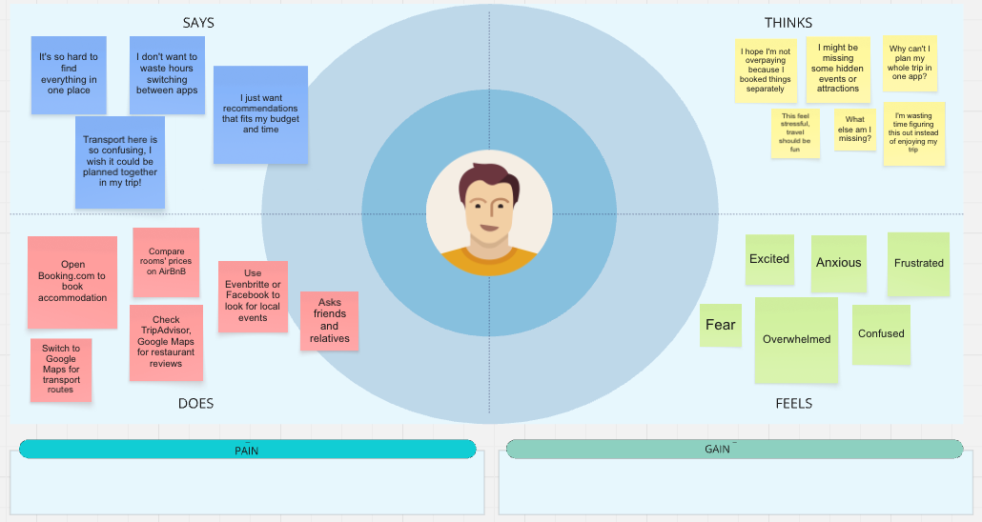
Secondary research revealed that the hospitality and tourism industries have been profoundly transformed by emerging technologies such as mobile cloud computing, the Internet of Things (IoT), artificial intelligence (AI), and blockchain. These innovations have led to the rise of Mobile Travel Applications (MTAs) that enable digitalised, technology-driven travel experiences (Sia et al., 2023). However, most existing travel applications focus on specific functions—such as flight booking, accommodation, or event discovery—forcing travellers to juggle multiple apps. Studies highlight that users often download and test numerous tourism-related apps, a process that is time-consuming and mentally exhausting (Garcia-Lopez et al., 2021).

To complement these findings, informal interviews and discussions were held with friends, colleagues, and workplace customers who travel regularly. The majority of respondents indicated that they relied on multiple applications, such as Google Maps or TripViewLite for transport, Airbnb and Booking.com for accommodation, and social media platforms like TikTok, Instagram, or Eventbrite for food, attractions, and local events. This fragmented process led to feelings of tiredness, confusion, and anxiety. Participants expressed frustration about the effort required to coordinate between platforms and the fear of missing deals or planning errors. Many also reported feeling uncertain about whether their self-made plans would meet expectations, indicating a need for reassurance and smarter assistance in planning.

3.2. Define - how you identified pain points
- Problem statement framed in human-centric terms
- Insights gained from empathy map & Maslow’s hierarchy of needs
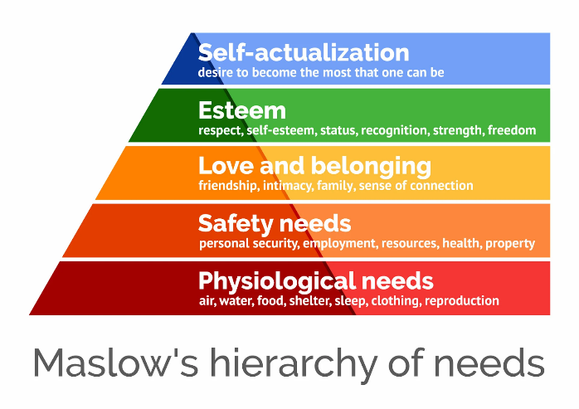
From Empathy Map, we recognised that customer is being tired and out of energy from being planning for their trips. They’re becoming less and less exciting about pre-trip planning. Tourists need an easier way to plan their journey because they feel overwhelmed by using multiple apps for bookings, food, and activities
From Mashlow’s hierarchy of needs
- Physiological & safety need: Tourists need a secure accommodation, safe and punctual transport, transparent cost
- Love and belonging: They desire to connect with locals, participate in the cultural events or activities, try the cuisine and also share experiences with friends and family
- self-Actualisation: Seeking authentic cultural experiences, learning, adventure
By mapping users needs to MAslow’s hierarchy, we see that while functional needs (safety, security, budgeting) are critical, higher-level needs like belonging, esteem, and cultural fulfillment strongly influence their satisfaction (Lynn writing draft)

    - Identify Pain Points
Findings from the empathy phase revealed that travellers often feel tired, anxious, and demotivated during the pre-trip planning stage. Many users expressed that the excitement of travelling fades due to the overwhelming process of managing multiple apps for flights, accommodations, transport, dining, and local events. This fragmented experience leads to decision fatigue, loss of enthusiasm, and decreased satisfaction even before the trip begins.
Users want a simpler and more cohesive way to plan their journey, where all functions are accessible in one place without switching between multiple platforms. They also desire reassurance and confidence that their plans are efficient, safe, and cost-effective.
    - Insights from Maslow’s Hierarchy of Needs
By mapping these findings against Maslow’s hierarchy of needs, it becomes clear that travellers’ challenges are not only functional but also emotional and aspirational:
- Physiological & Safety Needs: Travellers prioritise secure accommodations, reliable transportation, and transparent budgeting. The anxiety of booking through multiple channels makes them feel uncertain about safety and financial control.
- Love and Belonging: Beyond safety, users want to feel connected—to interact with locals, join cultural events, and share their experiences with friends and family, fulfilling their social and emotional needs.
- Self-Actualisation: Many travellers aspire to experience personal growth through authentic cultural engagement, adventure, and learning opportunities during their trips.
This analysis highlights that while functional reliability (safety, cost, booking efficiency) forms the foundation of travel satisfaction, emotional and self-fulfilment needs (connection, belonging, and authenticity) drive true enjoyment and loyalty.
    - Problem Statement
Travellers today feel overwhelmed, disconnected, and anxious when planning trips through multiple disconnected apps. They need an integrated, intelligent platform that simplifies trip planning, provides reassurance through AI-driven personalisation, and supports not only their functional needs for safety and organisation but also their deeper emotional desires for connection and fulfilment.

Ideate - brainstorming ideas (LOTUS Blossom diagram)
- Brainstorming techniques (Brainstorming, Worst Idea, SCAMPER, etc.)
  - Brainstorming: Generate as many raw ideas as possible for each petal. For example, We are coming with not only the flight booking and place to eat suggestions, but also the discount and loyalty program. We place ourselves as a traveller and list out as many possible ideas as possible for what we expect to have in the app for preparing the trip. Additionally, it also have to have what we want to do, try during the trip and what the features to satisfy our requirement and we brainstorm all of them out
  - SCAMPERS: Apply Substitute, Combine, Adapt, Modify, Put to another use, Eliminate, Reverse to each petal
- Lotus Blossom Diagram to expand solution ideas
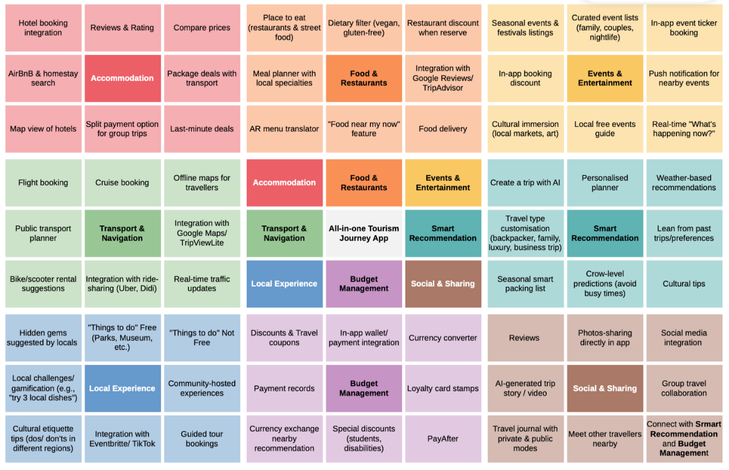
The ideate stage focused on generating innovative and user-centred solutions to the problems identified during the empathy and define stages. To explore a wide range of creative ideas systematically, the Lotus Blossom technique was adopted. This method allows designers to expand a central idea into detailed subcategories, ensuring that all aspects of the user journey are considered holistically.
The central concept of the Lotus Blossom diagram was the “All-in-One Tourism Journey App”—a unified digital platform that consolidates every stage of a traveller’s experience, from planning to sharing. Eight key subcategories were developed around this core idea: Accommodation, Food & Restaurant, Events & Entertainment, Transport & Navigation, Local Experience, Budget Management, Social & Sharing, and Smart Recommendation.
Each subcategory was then expanded into specific features that align with user needs and motivations identified through the empathy mapping and Maslow’s hierarchy analysis.
- Accommodation: Offers hotel, motel, and hostel booking options, complete with user reviews, ratings, and price comparisons. A map view helps visualise locations, while package deals and promotions support users’ physiological and safety needs for secure, budget-friendly lodging.
- Food & Restaurant: Provides a diverse list of dining options—including local street food and restaurants—with filters for dietary preferences (e.g., vegan, gluten-free). Integration with Google Reviews and TripAdvisor enhances credibility, while reservation discounts increase satisfaction.
- Events & Entertainment: Lists local festivals and seasonal events (e.g., Oktoberfest in Germany), along with cultural activities and curated event lists for families, couples, or nightlife seekers. Real-time “What’s Happening Now” updates encourage spontaneous exploration and fulfil belonging needs.
- Transport & Navigation: Includes flight booking and a public transport planner integrated with Google Maps or TripViewLite. Real-time traffic updates and bike/scooter rental suggestions ensure travellers move safely and efficiently.
- Smart Recommendation: Uses AI to generate personalised trip plans based on user input or past preferences. It allows users to customise experiences by travel type—backpacker, family, luxury, or business—supporting self-actualisation through tailored adventure.
- Local Experience: Highlights hidden gems and authentic attractions suggested by locals, integrating with platforms like Eventbrite and TikTok to provide both paid and free activities, fostering deeper cultural connection.
- Budget Management: Incorporates loyalty cards, in-app wallets, currency converters, and special discounts (e.g., for students or travellers with disabilities). These features enhance financial control and transparency, reducing planning stress.
- Social & Sharing: Enables users to share experiences, post reviews, and connect with other travellers. Integration with social media platforms allows for collaborative planning and community engagement, strengthening belonging and esteem needs.
By mapping these elements, the ideation process produced a comprehensive, interconnected ecosystem that responds to users’ functional, emotional, and aspirational needs. The final concept merges convenience with personalisation—transforming fragmented trip planning into a seamless, engaging experience that builds user confidence and travel satisfaction.

Testing
- Describe feedback approach (peer review, small user test)

Results and Implications

Prototype Description

AS-IS process and TO-BE process
The AS-IS travel planning process illustrates the current state of how tourists plan trips across multiple independent platforms, covering essential components such as flights, accommodation, events or activities, food or restaurants, local transport, and budget management. The process begins when a tourist decides to take a trip and selects a destination and travel date. From there, they must individually search, compare, and book services across different apps or websites — for example, using separate platforms for flights, hotels, activities, restaurants, and local transport. For each component, the user enters search information, compares available options, selects a service if satisfied (or repeats the search in other apps if not), fills out personal and payment information to finalize bookings, and receives confirmation from each provider. Only after managing all these separate confirmations is the user ready to “enjoy the trip.”
This current approach creates several pain points for users. Repetitive manual input forces tourists to repeatedly enter destination, date, and budget information across multiple apps, wasting time and increasing fatigue. The experience is fragmented, as bookings for flights, hotels, and activities are managed separately, requiring users to track multiple confirmations. There is no centralized budget control, making it easy to exceed planned spending. Users face high cognitive load due to switching between platforms for each component, which can be particularly confusing for less tech-savvy individuals or those with accessibility needs. Finally, repeatedly entering personal and payment information increases the risk of data leakage, financial fraud, and loss of privacy.

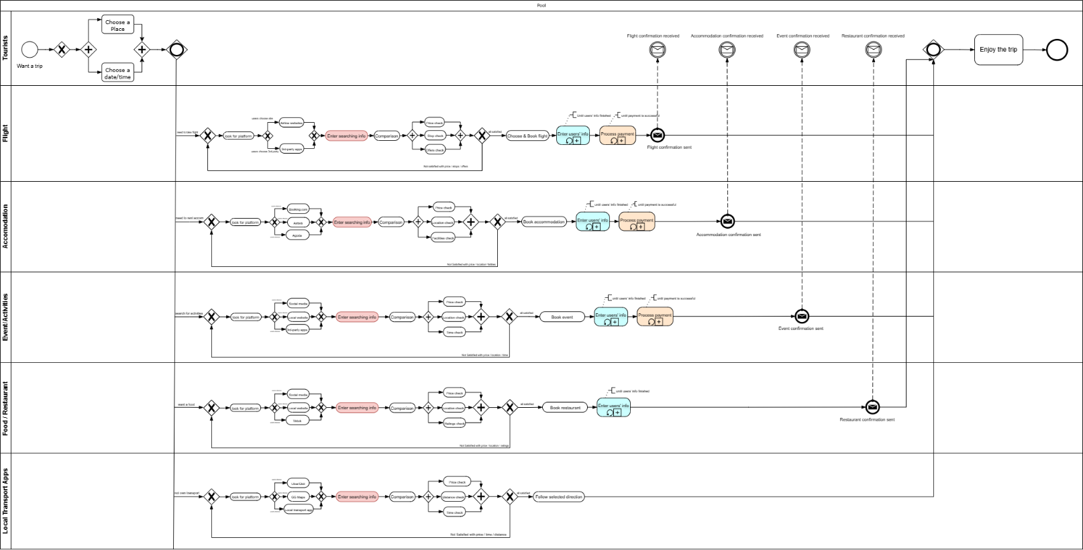

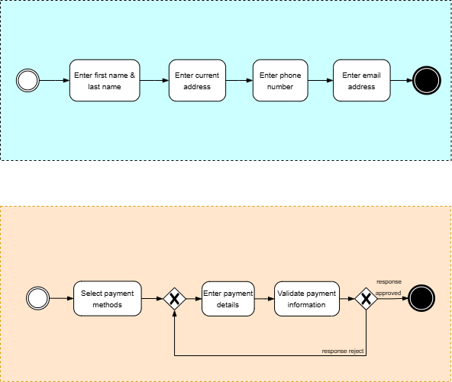


The TO-BE process represents the future state of travel planning through an all-in-one integrated web-based platform designed to overcome the inefficiencies of the current fragmented approach. In this enhanced model, tourists can manage their entire trip — including flights, accommodation, food, activities, transportation, and budget — within a single, seamless application environment. The process begins when users create a trip profile in the app by entering personal details, selecting a destination, and setting travel dates. Once the trip is created, the user’s information and preferences are securely stored in the database, enabling personalized recommendations and one-time payment authentication for all bookings. When the payments go through, the confirmations for each booking will be send to the users and store in the database of the current trip.
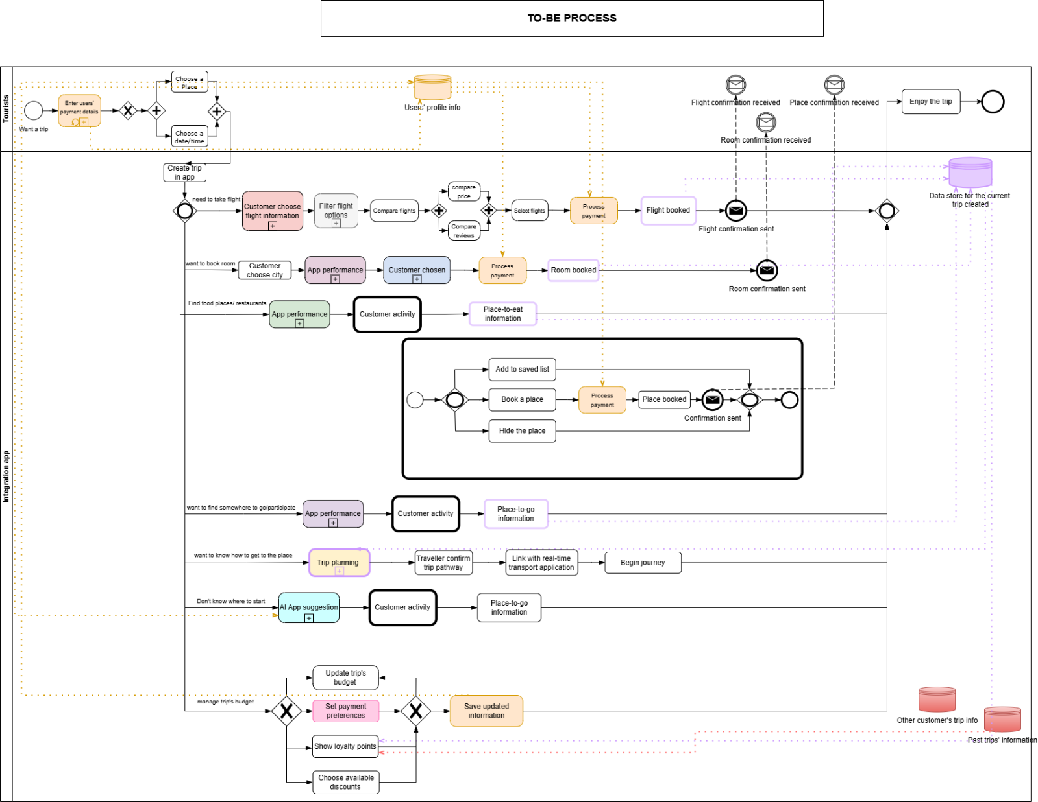

The system then centralizes all trip-related actions. For flight bookings, users input their travel preferences, apply filters (such as flight times, airline brand, or ticket price), compare options, and confirm their booking within the same interface. Similarly, for accommodation, the app lists available hotels with price comparisons, deals, and filtering options by location, amenities, facilities, etc. When users are satisfied, they can process payment immediately and get booking confirmations.
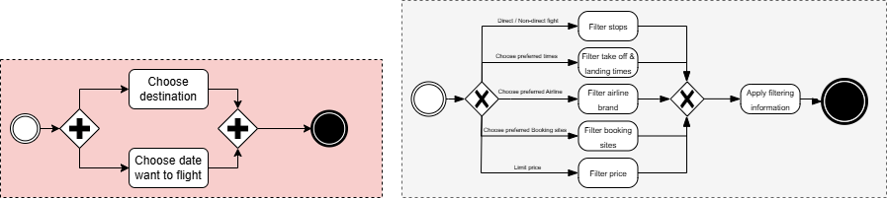

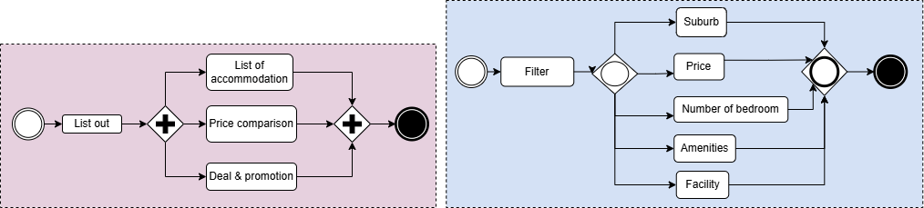

Food and dining searches allow users to explore restaurants or street food options, view reviews, compare prices, and either save, book, or hide venues from their itinerary. Activities and local attractions follow a similar workflow, which is to display real-time events, hidden gems, and recommend to-do lists that can be bookmarked or booked directly.
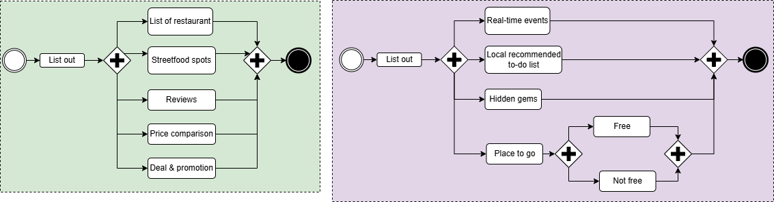


Transportation planning is integrated with real-time navigation in Google Maps, users can confirm destinations, view saved bookings (such as hotels or restaurants), and receive intelligent route suggestions via train, bus, ferry, or rideshare options. Once the users confirm pathway, they can start their journey to the input destination.
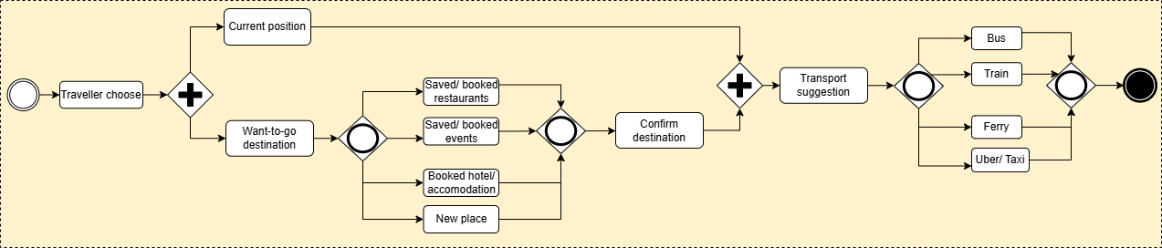

In terms of AI suggestion feature, which is for users who are unsure where to start, this new function collects the information from users’ past trips and other customer’s trips to prepare for the recommendation. This allows users to customise their travel type, such as they go with friends or family or they want it to be adventure or relax trip, the AI will create a unique trip based on users’ selection with a personalised planner. After that, these places will be saved to go when users confirm.
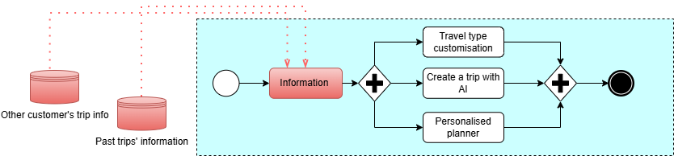

At any time, users can manage their trip budget, such as setting up payment preferences, viewing loyalty points recorded from history trips and completed missions, and accessing available discounts. These all features are all-in-one unified interface. Within the setting up payment preferences, users can set their preferred currency and choose preferred payment method, such as Pay After, In-wallet, or Credit / Debit Card.
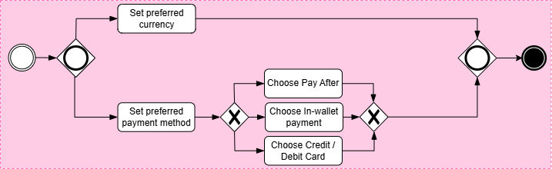

High-fidelity prototype - Web-based service
Our high-fidelity prototype, designed using Figma, presents a comprehensive web-based travel planning service that aims to minimise travellers’ worries, reduce anxiety, and eliminate the confusion caused by switching between multiple applications. The platform serves as an all-in-one travel companion, allowing users to plan, book, and manage every aspect of their trip seamlessly in one place.
Upon registration or login, users can start by creating a new trip either manually or through AI-assisted trip generation. By simply entering basic information such as trip name, date, and destination, the system generates a personalised trip page where all travel-related functions are conveniently centralised.
Within each trip, users can access five core functions — Flights, Accommodation, Food & Drink, Places-to-Go, and Events — each offering three interactive modes:
- Saved: Displays items the user has marked for later consideration but not yet booked.
- For You: Provides curated suggestions and deals tailored to the user’s destination.
- AI Recommendation: Generates intelligent recommendations aligned with the user’s preferences, profile data, or past trip choices.

The booking process for flights and accommodations is fully integrated, allowing users to select from various options (similar to existing travel websites) but with the added advantage of exclusive discounts. Booking confirmations are automatically sent via email and securely stored in the trip’s database for easy reference.
Unlike other platforms, our Places-to-Go feature includes both paid attractions and free local spots, offering travellers richer and more authentic experiences. The Events section further enhances cultural exploration by listing hidden or regional events that tourists may not easily discover elsewhere.
To support on-ground travel, the Transport function integrates with Google Maps, enabling users to find routes using local public transport systems. A key enhancement is the ability to search routes directly from saved or booked places, eliminating the need to switch between multiple apps.
The My Plan section allows users to view their schedule in two modes:
- Booked Mode: Displays detailed information about all confirmed bookings (e.g., restaurant name, date, pre-ordered meals).
- Overview Mode: Shows an organised weekly timetable of all booked activities, helping users avoid scheduling conflicts and visualise their entire trip easily.
Beyond individual trips, the user’s account includes a Budget Management and Loyalty System. Travellers earn reward points after completing trips or engaging in missions (such as sharing experiences or leaving reviews). These points can be redeemed for discounts — for instance, 40% off accommodation or 30% off for students and couples. Additionally, users only need to store their payment details once, making future bookings across all categories quick and convenient. The platform also includes a currency conversion tool to display real-time exchange rates between the user’s country and their travel destination.

The high-fidelity prototype, designed using Figma, demonstrates a fully functional web-based travel planning service that addresses the key pain points identified in the AS-IS process — fragmented systems, time-consuming app-switching, and disorganized trip management. This integrated platform acts as a digital travel assistant that enables users to plan, book, and manage every aspect of their journey in one seamless environment, thereby minimizing travellers’ stress and cognitive load.
Upon registration or login, users are guided to create a new trip through either manual setup or an AI-assisted trip generator. By entering basic trip information such as destination, date, and travel purpose, the system automatically constructs a personalized trip dashboard. This dashboard consolidates all travel operations into one place, eliminating the need to switch between multiple websites or applications. Within each trip, users can navigate five key modules — Flights, Accommodation, Food & Drink, Places-to-Go, and Events — each offering three dynamic interaction modes: Saved for bookmarked options, For You for curated deals, and AI Recommendations for intelligent, data-driven suggestions based on user history and preferences. This personalization directly resolves the problem of information overload and indecisive planning often faced by travellers.
The flight and accommodation booking functions are tightly integrated with trusted providers, featuring real-time availability, comparison tools, and automatic booking confirmation stored within the user’s trip page and email. Unlike conventional platforms, the Places-to-Go module enriches the user experience by showcasing both popular attractions and authentic local sites, promoting cultural immersion. The Events feature adds further value by uncovering hidden local festivals and gatherings that typical travel apps overlook, supporting more meaningful and spontaneous exploration.
To simplify mobility during travel, the prototype’s Transport integration connects directly to Google Maps APIs, allowing users to view routes between saved or booked locations without switching applications. This directly mitigates the inconvenience and fragmentation of existing travel planning tools. The My Plan section provides two modes — Booked Mode for confirmed activities and Overview Mode for visualizing itineraries — ensuring users can track their schedule efficiently and avoid overlaps.
Additionally, the platform introduces a Budget Management and Loyalty System that not only streamlines payments but also enhances user retention through reward incentives. By storing payment information once and applying real-time currency conversion, the system saves time, increases financial transparency, and supports a smooth, worry-free booking experience. Overall, this prototype offers an intelligent, user-centered, and cohesive solution that redefines travel planning through integration, personalization, and automation.

Business Model

How the Business Runs
The service connects travellers, local service providers, and travel partners on a single multi-sided platform. Travellers use the website to plan and manage their trips, while local businesses (such as hotels, restaurants, and event organisers) can list their services and offer exclusive deals to attract customers. Revenue will be generated through:
- Commission fees from bookings (flights, accommodation, events, etc.)
- Subscription partnerships with local businesses for premium listing visibility
- Advertising space for tourism boards and brands
- Affiliate marketing through discount codes and loyalty card usage
The loyalty system encourages user engagement and repeats purchases. Travellers earn reward points through bookings, reviews, and social media engagement, which can be redeemed for discounts or offers, increasing customer retention and brand loyalty.

Competitive Strategy
Our competitive strategy focuses on differentiation through integration and personalisation. Unlike traditional platforms that specialise in a single function (e.g., Google Maps for navigation or TripAdvisor for reviews), our service unifies all travel-related activities in one interface. This holistic design not only saves time but also reduces travellers’ anxiety and decision fatigue.
We also use AI-driven recommendations to create highly personalised experiences. By analysing user profiles, preferences, and past trip data, the system suggests suitable destinations, restaurants, events, and attractions that align with each traveller’s unique interests.
Furthermore, we form strategic partnerships with airlines, hotels, and local attractions to offer exclusive deals and lower prices—giving users a financial incentive to book through our platform rather than competitors.

How We Do Better Than Rivals
- All-in-One Platform: Unlike TripAdvisor, Expedia, or Google Travel, users do not need to switch between multiple apps. Everything from flights to event tickets can be planned, booked, and tracked in one place.
- AI Personalisation: Our platform learns from users’ previous trips to offer tailored suggestions, enhancing satisfaction and discovery.
- Local Event Discovery: We promote hidden local and cultural events that are often overlooked by major travel sites, offering authentic travel experiences.
- Budget and Loyalty System: Integrated reward points and budget tracking encourage repeat usage and provide financial value for loyal customers.
- Convenience and Integration: One-time payment setup and linked navigation through Google Maps integration make the experience smooth and worry-free.
In essence, our business model combines technological innovation, personalisation, and strategic partnerships to deliver a travel planning experience that is smarter, cheaper, and more enjoyable than any single-function competitor.

The proposed business model operates as a multi-sided platform connecting travellers, local service providers, and travel partners within a unified digital ecosystem. Travellers use the web-based platform to plan, book, and manage their entire journey, while local businesses — such as hotels, restaurants, and event organisers — can register to promote their services and offer exclusive deals directly to target customers. This interaction creates mutual value for both users and suppliers, supported by a diversified revenue model. Primary income streams include commission fees from bookings across flights, accommodations, and activities; subscription partnerships that allow businesses to gain premium listing visibility; advertising placements for tourism boards and brands; and affiliate marketing programs using loyalty points and discount codes to encourage engagement.
To enhance customer retention, the platform integrates a loyalty and reward system that incentivises repeat bookings and user participation. Travellers can accumulate reward points through activities such as completing bookings, leaving verified reviews, or sharing experiences on social media. These points can later be redeemed for discounts or exclusive offers, effectively increasing brand loyalty and customer lifetime value.
The platform’s competitive advantage lies in its differentiation through integration and personalisation. While conventional services like TripAdvisor, Expedia, or Google Travel focus on single aspects of the travel experience, this all-in-one platform consolidates every travel component — from flights and accommodation to dining, local events, and transport — into one cohesive interface. Through AI-driven recommendations, the system provides tailored suggestions based on users’ profiles, preferences, and past behaviours, reducing decision fatigue and improving satisfaction. Additionally, strategic partnerships with airlines, hotels, and local attractions enable the delivery of exclusive discounts, encouraging users to book through the platform. With its convenient one-time payment setup, budget tracking tools, and Google Maps integration, this business model redefines the travel experience through efficiency, personalisation, and meaningful local engagement.

Revenue Model
TripMate adopts a multi-sided platform (MSP) revenue model that facilitates value exchange between tourists, local service providers, and event organisers. This approach aligns with established MSP strategies, which emphasise network effects and monetisation diversification (Parker, Van Alstyne & Choudary, 2016; Bivona et al., 2020).
The platform’s primary income stream is derived from transaction-based commissions on bookings for accommodation, transportation, dining, and events. For example, a 12% commission on a $100 transaction yields $12 in revenue. At scale, this forms a stable foundation consistent with MSP practices in tourism (Evans & Schmalensee, 2015).
The second revenue stream originates from sponsored placements and promotional content purchased by local vendors and organisers. These advertisements—targeted through geolocation and behavioural analytics—provide high visibility to relevant audiences, utilising cross-side spillover effects to convert user engagement into monetizable business interest (Reinhold et al., 2022).
The third stream comprises premium subscription services offering users advanced features such as ad-free access, offline itineraries, and early access to limited-time offers. Assuming 10,000 monthly active users and an average revenue per user (ARPU) of $2, projected annual revenue is approximately $240,000. This diversified model ensures scalability, affordability, and long-term sustainability.
Our revenue is generated through multiple streams:
- Commission Fees (60%): Earned from bookings of flights, accommodations, and local experiences (estimated 8–12% commission per transaction).
- Business Subscriptions (20%): Local partners can pay a monthly fee (AUD 50–100) for premium listings and higher algorithmic ranking.
- Advertising and Affiliate Marketing (15%): Tourism boards and travel brands can promote their offers on our platform.
- Loyalty Partnerships (5%): Redeemable offers and brand collaborations with airlines and hospitality groups.
Over the first operational year, we estimate an average of 10,000 users, with 30% converting into active bookers. With an average transaction value of AUD 500, this could generate approximately AUD 400,000–500,000 in commission revenue.

Joint Value Proposition: State how both customers and business benefit from your solution
TripMate’s joint value proposition is rooted in value co-creation, aligning with the service-dominant logic (S-D logic) and the evolution of smart tourism platforms (Vargo & Lusch, 2008; Chuang et al., 2023).
For tourists, the app simplifies fragmented travel planning by integrating transport, accommodation, and event information into one intelligent interface. Personalised, location-aware recommendations based on real-time context reduce cognitive effort and enhance access to underrepresented cultural experiences, supporting deeper engagement and satisfaction.
For local businesses and event organisers, TripMate provides a data-driven, cost-effective channel for targeted customer acquisition. Vendors can advertise directly to interested users, analyse engagement patterns, and dynamically adjust offers. This two-sided interaction fosters mutual benefit, platform adoption, and contributes to the sustainable development of urban tourism ecosystems

We offer travellers a convenient and stress-free travel experience through one platform where they can plan, book, and manage their entire trip. For partners such as airlines, hotels, restaurants, and event organisers, the platform provides a direct channel to reach targeted customers, increase visibility, and offer exclusive deals. Our AI-driven personalisation and loyalty system ensure that every user journey feels unique and valuable
We attract customers through targeted digital marketing, social media partnerships, and influencer campaigns. Retention is strengthened through a loyalty point system, AI-driven recommendations, and seamless user experience—reducing frustration and increasing trust. By centralising all bookings and payments in one platform, users save time and avoid repetitive data entry, significantly improving satisfaction.
Customer support costs are estimated to be 30–40% lower than competitors due to the system’s intuitive design and AI chat assistance, which reduces the need for human intervention.
Our platform outperforms existing rivals like TripAdvisor, Expedia, and Google Travel by providing a unified, personalised, and more affordable experience. Through exclusive partner discounts, AI-generated trip ideas, and integrated public transport routing, we ensure that users not only plan smarter but also travel happier.

Practical Value
TripMate delivers measurable improvements in operational efficiency, user experience, and stakeholder engagement.
For travellers, the app consolidates complex planning tasks and reduces itinerary preparation time by an estimated 40–60%, thereby lowering decision fatigue. By curating real-time, location-specific cultural content, TripMate is projected to increase participation in local events by up to 30%, consistent with findings in platform-enabled tourism studies (Chuang et al., 2023).
For local businesses, the platform serves as a low-cost digital marketing alternative. Integration is expected to result in a 10–20% increase in bookings or foot traffic, particularly for small and medium-sized enterprises (SMEs). Real-time promotion tools further enhance conversion efficiency.
For event organisers, TripMate enables RSVP tracking, bundled service offers, and demand forecasting, improving logistical planning and attendance outcomes. Overall, the platform supports ecosystem-wide optimisation through data-informed coordination and stakeholder integration

The proposed web-based travel planning platform delivers significant practical value by addressing real issues faced by modern travellers and industry stakeholders.
For travellers, the platform provides a seamless, all-in-one experience that reduces the stress and confusion of using multiple applications for booking, navigation, and planning. By centralising all travel needs—flights, accommodation, attractions, food, events, and transportation—into one platform, users save both time and effort, making trip management simpler and more enjoyable. The AI-powered recommendation system adds further value by suggesting personalised destinations and activities aligned with users’ interests and travel history, enhancing satisfaction and confidence in their choices.
The platform’s integrated payment and booking system reduces human error, missed reservations, and data re-entry, resulting in smoother travel experiences. The overview timetable and budget management features help travellers maintain better control of their schedules and spending, ensuring trips run efficiently without overlaps or financial surprises.
For local businesses and travel service providers, the platform offers a direct digital channel to reach targeted travellers through listings, advertisements, and AI recommendations. This not only increases visibility but also supports local economic growth by promoting regional attractions and hidden cultural events that are often overlooked on larger platforms.
The loyalty program provides additional value through repeat engagement and cost savings. Users earn redeemable points for completing bookings, reviews, and social media sharing, which encourages ongoing participation while offering tangible financial rewards such as discounts and special offers.
From an operational perspective, the platform’s intuitive interface and AI-assisted support system lower maintenance and customer service costs by reducing the need for manual assistance. Overall, the service generates practical value by creating a smarter, more connected travel ecosystem—benefiting both travellers and businesses through efficiency, personalisation, and convenience.

Conclusion
- Restate project aim
- summary of approach (design thinking, prototype)
- Key outcomes (prototype value & potential impact)
- Benefits of BPM lifecycle

Recommendations

References
Sia, P. Y.-H., Saidin, S. S., & Iskandar, Y. H. P. (2023). Systematic review of mobile travel apps and their smart features and challenges. Journal of Hospitality and Tourism Insights, 6(5), 2115–2138. https://doi.org/10.1108/jhti-02-2022-0087

Garcia-Lopez, E., Garcia-Cabot, A., de-Marcos, L., & Moreira-Teixeira, A. (2021). An experiment to discover usability guidelines for designing mobile tourist apps. Wireless Communications and Mobile Computing, 2021(1), 1–12. https://doi.org/10.1155/2021/2824632

